**With smaller Standard errors for capture probability**

N <- 100000 # population size

theta <- c(0.8,0.6) # sub sample proportions

phi <- .9

lambda_B <- 1.e-10 # since this is converted to log form, have to give

# a very small number instead of zero

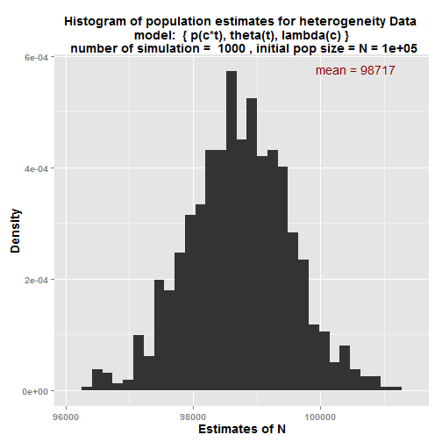

$sim.means

mean_estimate

N 98,717

N_M 47,965

N_F 50,752

p_1M 0.252

p_1F 0.217

p_2M 0.321

p_2F 0.338

lambda_M 0.486

lambda_F 0.514

theta_1 0.8

theta_2 0.6

**With larger Standard errors for capture probability**

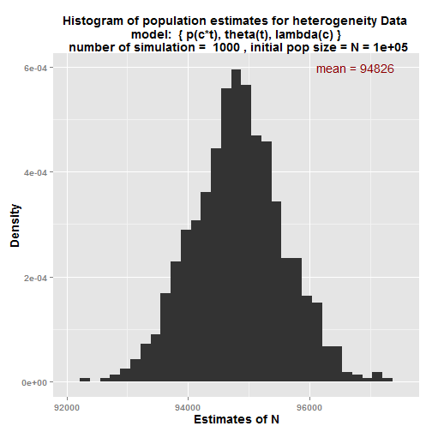

$sim.means

mean_estimate

N 94,826

N_M 45,999

N_F 48,827

p_1M 0.268

p_1F 0.233

p_2M 0.339

p_2F 0.355

lambda_M 0.485

lambda_F 0.515

theta_1 0.8

theta_2 0.6

**Check the code using simple Lincoln Petersen estimates**

N <- 100000 # population size

theta <- c(1,1) # sub sample proportions

phi <- .99999999 # Since this is converted to logit, give a value

# closer to 1 instead of value 1

lambda_B <- 1.e-10 # since this is converted to log form, have to give

# a very small number instead of zero

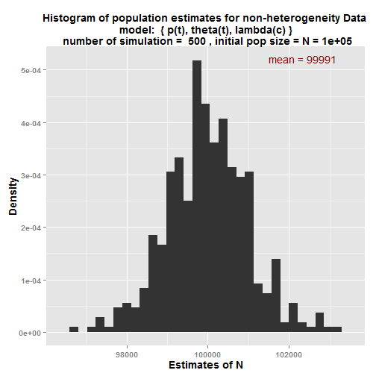

initial.param.values mean_estimate

N 1e+05 99,991

N_M 40,000 40,005

N_F 60,000 59,986

p_1M 0.2 0.2

p_1F 0.2 0.2

p_2M 0.3 0.3

p_2F 0.3 0.3

lambda_M 0.4 0.4

lambda_F 0.6 0.6

theta_1 1 1

theta_2 1 1

**Generate data similar to Mille Lacs Walleye data set and analysis**

N <- 205500 # population size

theta <- c(0.9939,0.08291) # sub sample proportions

phi <- 0.999999

lambda_B <- 1.e-10 # since this is converted to log form, have to give # a very small number instead of zero

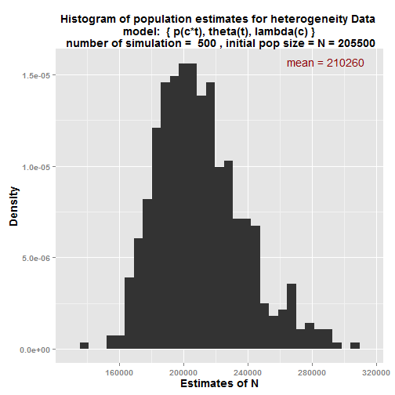

$sim.means

mean_estimate

N 210,260

N_M 69,931

N_F 140,329

p_1M 0.077

p_1F 0.012

p_2M 0.008

p_2F 0.021

lambda_M 0.334

lambda_F 0.666

theta_1 0.994

theta_2 0.083

**Generate data similar to Mille Lacs Walleye data set and analysis**

**Fitting a different model (simple Petersen)**

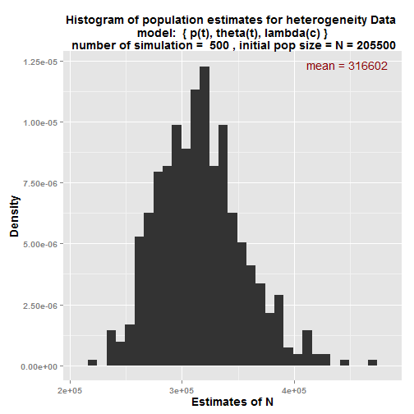

$sim.means

mean_estimate

N 316,602

N_M 233,877

N_F 82,726

p_1M 0.022

p_1F 0.022

p_2M 0.011

p_2F 0.011

lambda_M 0.739

lambda_F 0.261

theta_1 0.994

theta_2 0.083

################# Generate data with different scenarios #####################

###### With smaller standard deviation for capture probabilities and larger ###

###### correlation and category proportions are different considerably ###

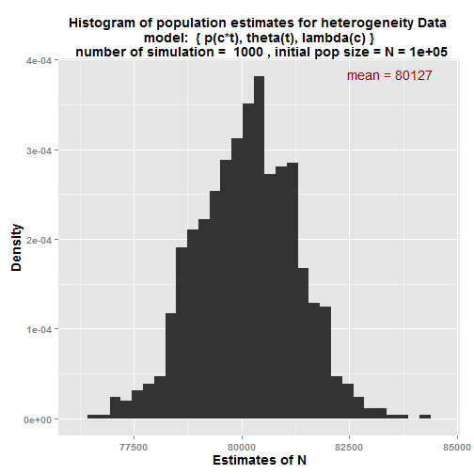

Time 1 time 2 proportion

M1 0.1 0.05 0.15

M2 0.3 0.15 0.15

F1 0.05 0.15 0.35

F2 0.15 0.45 0.35

$sim.means

mean_estimate

N 80,127

N_M 24,059

N_F 56,068

p_1M 0.25

p_1F 0.125

p_2M 0.113

p_2F 0.337

lambda_M 0.3

lambda_F 0.7

theta_1 0.8

theta_2 0.6

################# Generate data with different scenarios #####################

###### With smaller standard deviation for capture probabilities and larger ###

###### Correlation and category proportions are different considerably ###

**Model : { p(t), theta(t), lambda(c)}**

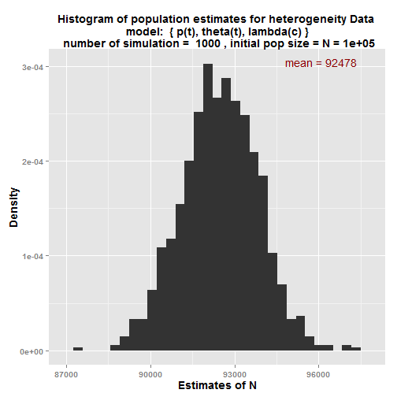

Time 1 time 2 proportion

M1 0.1 0.05 0.15

M2 0.3 0.15 0.15

F1 0.05 0.15 0.35

F2 0.15 0.45 0.35

$sim.means

mean_estimate

N 92,478

N_M 25,829

N_F 66,649

p_1M 0.141

p_1F 0.141

p_2M 0.234

p_2F 0.234

lambda_M 0.279

lambda_F 0.721

theta_1 0.8

theta_2 0.6